|  |  |
| --- | --- |
| cetlogo ***CHEMICAL ENGINEERING TRANSACTIONS***  ***VOL. xxx, 2024*** | A publication of  aidiclogo_grande |
| The Italian Association  of Chemical Engineering  Online at www.cetjournal.it |
| Guest Editors: Valerio Cozzani, Bruno Fabiano, Genserik Reniers  Copyright © 2024, AIDIC Servizi S.r.l. **ISBN** 979-12-81206-11-3; **ISSN** 2283-9216 | |

Insights into the Vulnerability of Industrial Infrastructure against Lightning Strikes Applied to the Italian Context.

David J. Castro Rodriguez\*, Morena Vitale, Gabriele Baldissone, Antonello A. Barresi, Micaela Demichela.

Department of Applied Science and Technology, Politecnico di Torino Corso Duca Degli Abruzzi 24, 10129 Torino, Italy

david.castro@polito.it

This study delves into the impactful realm of lightning strikes, a meteorological phenomenon that poses substantial risks to the process industry by potentially triggering technological disruptions. This paper focuses on the territorial aspects linked to the lightning-triggered NaTech events, using the Italian geographical context as a case study. The novel insights gained from a historical analysis of NaTech events caused by lightning in the process industry allowed for quantifying frequencies and conditional probabilities governing final scenarios. These insights also shed light on associated infrastructural details, including industrial equipment and the macro-sectors involved. These data were linked with the territorial distribution of the major hazard establishments in Italy and further associated with the ground lightning density in specific territories. Focusing on different locations of hypothetical plants, the differences in their susceptibility to suffering lightning-triggered Natech disasters were compared. The findings and some conceptual ideas of this research have implications for stakeholders and technicians engaged in risk assessment. This research specifically contributes to increasing vulnerability awareness against lightning strikes, not only from a functional deterministic point of view but also from a territorial comprehensive perspective.

**Keywords:** Ground lightning density, NaTech, lightning, major hazard establishments, territorial vulnerability.

* 1. Introduction

The industrial sector is emphasized as having a greater likelihood of incurring significant losses caused by natural disasters (European Commission, 2018). Consequently, the European Commission has issued Directive (EU) 2022/2557 (European Commission, 2022) to increase the ability of critical entities to withstand disruptions, including natural hazards, and to enhance resilience. This directive explicitly states that risk assessment must be integrated with the sector-specific regulations of the European Union, referring explicitly to the 2012/18/EU Seveso III Directive (European Commission, 2012). In simple words, it means that at least some of the major hazard industries (MHIs) are considered critical entities. Moreover, MHIs are controlled because they pose a significant risk due to their potential to cause technological scenarios because of internal failures. Furthermore, these process plants are susceptible to disruptions caused by the natural hazards inherent to their locations, which may trigger technological accidents involving the release of hazardous substances (Krausmann et al., 2017). These events, which are generally known as NaTech, may cause catastrophic consequences for the surrounding population, the environment, the industrial infrastructure, and the overall territorial dynamics.

While NaTech events in the process industry are causing great concern in the academic community (Krausmann and Necci, 2021; Ricci et al., 2021; Suarez-Paba and Cruz, 2022), accurately predicting the vulnerabilities of critical industrial infrastructures remains challenging. Historical record analysis has been demonstrated to be essential for assessing the probability of damage to industrial infrastructure impacted by diverse natural hazards (Cozzani et al., 2010; Krausmann et al., 2011; Ricci et al., 2023). However, the intensity, frequency, and extension of the impacts of natural disasters are rarely registered in industrial databases where the data are recorded (Reniers et al., 2018). Therefore, the influence of the previous factors in NaTech scenarios is difficult to quantify or hypothesize in association with the heterogeneous attributes connected with MHIs, such as production technologies, kinds of plants, vulnerable equipment, hazardous substances detained, and different geographical realities. Given the connection between the latter and the industrial susceptibilities against specific natural hazards in such territories, vulnerability assessment requires not only the calculation of probabilities of functional attributes based on historical records but also its territorial contextualization.

Lightning strikes, for example, are prominent meteorological events linked to climate change, and their frequency and severity are expected to increase. A comprehensive study of 9100 records about NaTech events in the process industry found that lightning strikes ranked fourth among the twelve natural factors analyzed, accounting for 11.3% of the total records. Specifically, lightning-triggered NaTech events present a critical trade-off in the process industry, based not only on their frequency of occurrence but also on their catastrophic consequences (Ricci et al., 2021). They can lead to severe off-site loss of containment of dangerous substances, weighing between 100 kg and 1000 kg 35% of the time and more than 1000 kg 38%, respectively (Renni et al., 2010). Moreover, the ignition probability of flammable substances after lightning strikes (82%) (Krausmann et al., 2011) is higher than that reported for conventional scenarios. Furthermore, fires caused by lightning strikes in tanks storing flammable substances are often initiators of the domino effect (Misuri et al., 2020), since lightning is known to have the power to affect nearby equipment in a chain reaction (Necci et al., 2014).

Even though lightning is a well-known threat, industry protective systems and preventive measures may not always be contextualized to the territorial characteristics connecting meteorological features with the establishment location. For instance, the density of lightning on the ground (lightning/year·km2) is not homogenous known data, which may have a diverse influence across the different locations. Hence, given the elements discussed before, the goal of this research is to contextualize the functional vulnerabilities obtained from a previous lightning-triggered historical analysis conducted in the process industry into the territorial characteristics of the plant location, aiming to strengthen vulnerability awareness against this multi-risk phenomenon. The Italian territorial distribution for MHIs (Seveso establishments) was used as a case study.

* 1. Materials and Methods

2.1 Functional and territorial factors at large scale

Italy ranked third among the Member States with a higher number of establishments, slightly above 8% of the European total with 974 establishments at the end of 2023 (ISPRA, 2023). To facilitate spatial data representation, from the information available in the Italian national inventory for MHIs, the 39 categories for industrial activities used in the transposed Italian legislation for Seveso III were clustered in macro-sectors. This classification in macro-sectors was tailored to address previous criteria used by various authors in the fields of NaTech and process safety (Casson Moreno et al., 2018; Ricci et al., 2021). The macro-sectors that match MHIs characteristics were: i) chemical and petrochemical; ii) storage and warehousing; iii) power production; iv) bioprocess; and v) manufacturing. In addition, the category “other” was introduced considering that in the Italian inventory, the category “other activity not specified in the list” has 85 plants, which does not allow the classification in macro-sectors. Subsequently, the macro-sectors were represented on a large scale as pie charts for each region, aiming to put together their geographical distribution with the corresponding density of lightning to the ground (*Ng*).

Regarding *Ng*, it indicates the average yearly number of lightning strikes per square kilometer (lightning/year·km2). After Electrotechnical Committee (CEI) Guide 81-3: 1999, ─“Average values of the number of lightning strikes on the ground per year and a square kilometer of the municipalities of Italy in alphabetical order,”─ was repealed in 2014, *Ng* started to be calculated utilizing nationwide ground lightning location networks (LLS). Geographical coordinates can be used to obtain the values of specific locations from the CEI through the online CEI application (CEI ProDis). Although the document regarding the average number of lightning strikes per year and square kilometer in Italian municipalities, assigned values of *Ng* to three different areas in Italy as 4, 2.5, or 1.5 lightning per year per km2 respectively (Sabatino and Cordisco, 2013), no longer holds normative status, it can be used as a first glance to associate lightning territorial vulnerability to MHI distribution. In addition, the CEI ProDis website application keeps an Italian map visualization, divided into three qualitative categories (Comitato Elettrotecnico Italiano, 2022). These categories are represented by different colors (high-red, medium-green, and low-blue), which can be used to contrast the consistency of the discussions hereinafter.

2.2 Functional and territorial factors focus on the industrial context scale

First, the insights concerning lightning-triggered NaTech in the process industry were conducted using a NaTech-driven dataset of 689 records that can be consulted in an open repository (Castro Rodriguez et al., 2023a). This dataset consisted of NaTech events up until 2022 and was built using the open-source industrial-accidents databases ARIA, eMARS, TAD IChemE, eNATECH, NRC, and CSB. Some outputs from the lighting-triggered NaTech-driven dataset analysis were tailored to the present case. For instance, the relative frequency of the classifiable records concerning the vulnerable macro-sectors against lightning strikes was determined. In addition, conditional probabilities among different functional attributes of interest, such as macro-sectors, equipment, and final scenarios, were calculated. Further details regarding the methods used, the definition of categories, and the data analysis can be found in Castro Rodríguez et al. (2024).

Second, only functional probabilities were used to compare how sensitive might be against lightning strikes, two different plants belonging to the same macro-sector but hypothetically located in different regions. This showed that the results were not consistent when the location factor was not taken into account.

* 1. Results

3.1 Functional and territorial factors at large scale

Figure 1 depicts, on a large scale, the distribution of MHIs in Italy clustered in macro-sectors for each region. This distribution should be contrasted with the Italian map for the distribution of Ng in three categories available on the CEI ProDis website (Comitato Elettrotecnico Italiano, 2022).

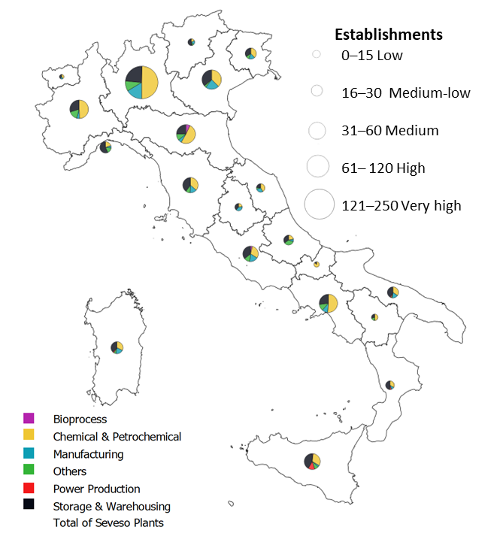

*Figure 1: Regional distribution of the industrial macro-sectors for Italian MHIs.*

High concern is raised by the greater level of industrialization observed in the northern part of Italy (Ricchiuti et al., 2007), where Lombardy emerges as the foremost region with 248 establishments, followed by significant contributions from Veneto (87), Emilia-Romagna (86), and Piedmont (82). In the southern part of the country, the prominence of industrialization is noted in the Campania region, with 79 establishments. Up to this point, Figure 1 merely offers a visual representation of known data. However, it is noteworthy that the pie charts predominantly depict the “Chemical and Petrochemical,” “Storage and Warehousing,” and “Manufacturing” macro-sectors, with values up to 85% of all critical MHIs in Italy.

Contrasting the information in Figure 1 with the Italian map for the distribution of *Ng*, it is alarming how almost all regions with a very high or high quantity of establishments, as mentioned previously, correspond to zones of medium (green) or high (yellow-red) *Ng* based on the dynamic distribution of colors (CEI ProDis website). On the other hand, there are regions with a medium or medium-low quantity of establishments that fall under zones with significant *Ng*, such as Friuli-Venezia Giulia, Liguria, or Lazio. It is important to consider both the total number of facilities and their density when correlating meteorological data. Factors such as geographical extension or the eventual clustering of establishments in specific zones influence density. For example, Liguria and Friuli-Venezia Giulia both have 30 establishments in a zone with similar *Ng* color contrasts. However, there is a higher chance that a lightning strike will damage one plant in Liguria than in Friuli-Venezia Giulia because the area where Liguria has 30 MHIs is 0.68 times smaller than the area where Friuli-Venezia Giulia has 30 MHIs. When looking at NaTech events on a large scale, these issues put them in context by including both functional factors (macro-sectors as technical attributes) and territorial factors linked to the meteorological information of concern (Ng). This function-location perspective requires the attention of stakeholders at different decision-making levels, such as operators, regulators, technicians, and local planners, to enhance vulnerability awareness and strengthen the decision-making processes.

3.2 Functional and territorial factors focus on the industrial context scale

Figure 2 shows the vulnerable macro-sectors against lightning strikes.

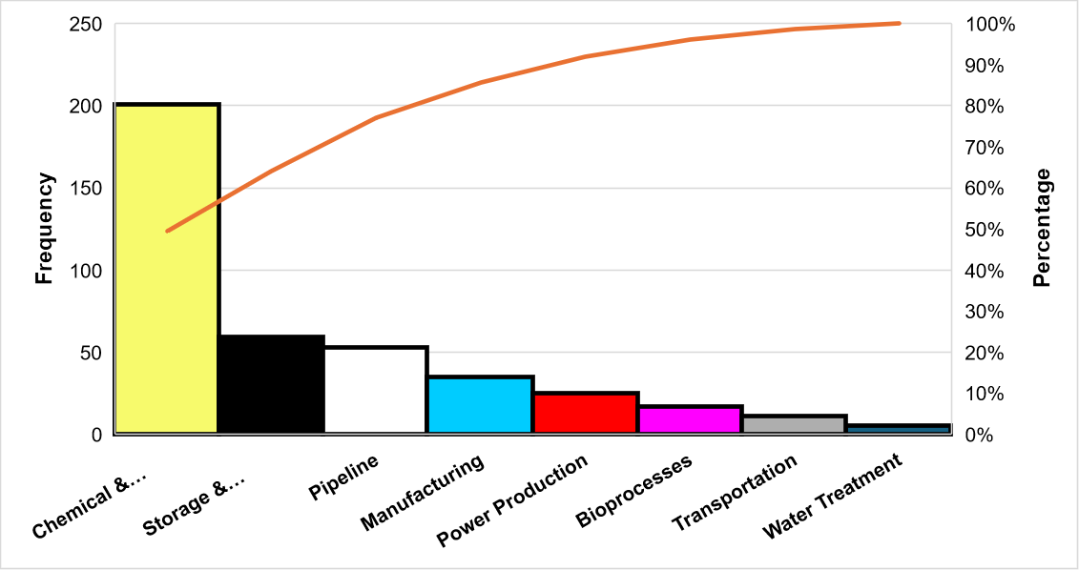

Figure 2: Pareto diagram for macro-sectors vulnerability against lightning strikes within the process industry.

As can be seen, "Chemical & Petrochemical" (yellow) and "Storage and Warehousing" (black) account for up to 60% of the global NaTech events caused by lightning strikes in the process industry. Furthermore, if “manufacturing” is added, a total of 72% of the NaTech events triggered by lightning in the process industry are totalized. This is a clear match between Figure 2 and Figure 1, where the same macro-sector categories appear as the most frequent under the Italian distribution of MHIs. Since this high vulnerability has been detected, special attention should be given to withstand the potential lightning impact on the facilities. In this line, Table 1 shows the conditional probabilities for categories of vulnerable equipment given the most frequent macro-sectors in Italian MHIs.

Table 1: Conditional probabilities for categories of vulnerability equipment given the most critical macro-sectors within Italian MHIs.

|  |  |  |  |  |  |  |  |
| --- | --- | --- | --- | --- | --- | --- | --- |
| Equipment | Process | Storage equipment | Pipework | Electric & Electronic | Machinery | Flares & Stakes | Other |
| Chemical & Petrochemical | 0.08 | 0.46 | 0.03 | 0.32 | 0.07 | 0.02 | 0.03 |
| Storage & Warehousing | 0 | 0.79 | 0.02 | 0.11 | 0.05 | 0.01 | 0.01 |
| Manufacturing | 0.02 | 0.48 | 0.07 | 0.28 | 0.01 | 0.03 | 0.11 |

The information in Table 1 may be useful during the assessment process for the mitigation of the lighting NaTech events on industrial equipment. Despite the three categories of macro-sectors compared, it can be appreciated how “storage equipment” and “electric equipment and electronic devices” comprise the industrial items most susceptible to lightning strikes. In addition, Table 2 shows further interplays between the probabilities of final scenarios for these two critical equipment categories (data from historical analysis).

Table 2: Conditional probabilities for technological scenarios given the failure of the vulnerable equipment against lightning strikes.

|  |  |  |  |  |  |  |
| --- | --- | --- | --- | --- | --- | --- |
| Equipment | Fire | Explosion | Release without  consequences | Toxic gas  dispersion | Environmental contamination | Multiple scenarios |
| Storage Equipment | 0.49 | 0.05 | 0.15 | 0.00 | 0.13 | 0.18 |
| Electric & Electronic | 0.08 | 0.01 | 0.52 | 0.02 | 0.32 | 0.05 |

As can be appreciated, “fire” is the most probable outcome for storage equipment, 49% of the time, as its energetic charge frequently ignites the stored substances. This finding is consistent with the reported probabilities for ignition resulting from lightning-induced events, as well as the research conducted by Ricci et al. (2021). The same authors highlighted the release with no further consequences (R-NFC) as the most common scenario triggered by all NaTech events, with a general 45%, consistent with the value obtained for the “Electric & Electronic” category (52%). From a phenomenological point of view, often the disruptions caused by these failures are involved in the indirect pathway of the development of NaTech, which means involving utilities or impairments that degrade the system performance or impede the failure mitigation but do not directly impact the dangerous substance.

The vulnerabilities of functional factors can be deepened by attending to other attributes of interest extracted from the original dataset, such as source and state of damage, categories and quantity of substances detained, presence of safety barriers, and so on. Further details can be consulted in Castro Rodríguez et al. (2024).

During the examination at a large scale of functional and territorial factors (refer to subsection 3.1), there were some differences concerning the interplays between both the lightning and the establishment territorial densities. These attributes are seldom reported in open industrial accident databases (Krausmann et al., 2011; Reniers et al., 2018). This issue makes it hard to distinguish vulnerability differences between establishments falling under the same macro-sector categories but located in diverse areas. Thus, whereas functional elements are used for quantitative site evaluations, the territorial component is generally overlooked.

In theory, if two hypothetical establishments belong to the "chemical and petrochemical" macro-sector, for example, Plant A from Liguria (30 establishments/region) and Plant B from Apulia (30 establishments/region), they should have the same conditional probability for sub-categories of equipment. For instance, according to Table 1, the likelihood of being affected by lightning in the category “storage equipment” is always 0.46 for both plant A and plant B. However, not only is the extension of Apulia 3.6 times higher, but the Ng of Apulia results are lower. Therefore, it is readily apparent that there exists a factor that conditions the infrastructural vulnerability assessment against lightning strikes between Plant A and Plant B, depending on their territorial contexts.

3.3 Ongoing implications

The previous discussion on the lightning factor is generalizable to other natural hazards, aiming to comprehensively assess industrial vulnerabilities as a first step to enhance resilience against NaTech events. Specifically, the importance of the augmented territorial perspective has implications for improving the leading indicators used to estimate the NaTech potential at the industrial context scale. For instance, throughout ongoing research, a “location priority factor” will be integrated into the NaTech indicator used in previous work (Castro Rodriguez et al., 2023b), addressing conceptual ideas that are here presented as preliminary criteria (the list below is not exhaustive):

* Differences in the spatial influence of each natural hazard on the industrial context under consideration,
* Specific vulnerability of the kind of industrial infrastructure of concern against specific natural hazards,
* Potential interactions among natural hazards causing cascading effects,
* Territorial density of infrastructures in the location of interest and synergy with neighboring infrastructure,
* Coping capacity inside and outside the plants.
  1. Conclusions

The most common macro-sectors in Italian MHIs distribution resulted in “chemical and petrochemical,” “storage and warehousing,” and “manufacturing.” These macro-sectors are frequently located in areas with medium to high lightning density on the ground, and they are also among the most vulnerable to lightning strikes, according to a historical analysis of lightning-triggered NaTech events. From a probabilistic perspective, no differences were found when comparing two hypothetical establishments belonging to the same macro-sector. On the other hand, when the territorial component was introduced, there were highlighted differences in the likelihood between the hypothetical establishments, considering both the density of establishments and lightning. These issues have a potential impact on vulnerability awareness against lighting and the consequent decision-making process concerning lightning protection measures. This study emphasizes the importance of combining quantitative analysis from historical records with the territorial perspective component to comprehensively evaluate the infrastructure vulnerability to natural hazards.

Conceptual ideas were presented as preliminary criteria with implications for further development of a priority factor that considers territorial aspects at the industrial context scale. Finally, this study offers methodological generalization for the territorial analysis of other natural hazards impacting industrial infrastructure.

Acknowledgments

This study was carried out within the RETURN Extended Partnership and received funding from the European

Union Next-GenerationEU (National Recovery and Resilience Plan – NRRP, Mission 4, Component 2, Investment 1.3 – D.D. 1243 2/8/2022, PE0000005).

References

Casson Moreno, V., Reniers, G., Salzano, E., Cozzani, V., 2018, Analysis of physical and cyber security-related events in the chemical and process industry, Process Safety and Environmental Protection 116, 621–631, <10.1016/j.psep.2018.03.026>.

Castro Rodriguez, D.J., Tufano, C., Vitale, M., Mietkiewicz, J., Baldissone, G., Barresi, A., Demichela, M., 2023a, Dataset: NaTech events triggered by lightning within the process industry, Mendeley Data, V4, <10.17632/fff64w3rzn.4>.

Castro Rodriguez, D.J., Pilone, E., Camuncoli, G., Demichela, M., 2023b, Implementation of a Natech Vulnerability Index in a Seveso Plant, Chemical Engineering Transactions 100, 43–48. <10.3303/CET23100008>.

Castro Rodríguez, D.J., Mietkiewicz, J., Vitale, M., Baldissone, G., Barresi, A.A., Demichela, M., 2024, NaTech triggered by lightning: Novel insights from past events in the process industry. Preprint available at SSRN <10.2139/ssrn.4671650>.

Comitato Elettrotecnico Italiano, 2022, CEI PRODIS: L’applicazione online del CEI che consente l’accesso ai dati di DENSITÀ CERAUNICA, <prodis.ceinorme.it/home.html?sso=y>.

Cozzani, V., Campedel, M., Renni, E., Krausmann, E., 2010, Industrial accidents triggered by flood events: Analysis of past accidents, Journal of Hazardous Materials 175, 501–509. <10.1016/j.jhazmat.2009.10.033>.

European Comission, 2012, Directive 2012/18/EU on the control of major-accident hazards involving dangerous substances, amending and subsequently repealing Council Directive 96/82/EC, Official Journal of the European Union, L 197/1, 1-37.

European Commission, 2018. Report from the Commission to the European Parliament and the Council on the implementation of the EU strategy on adaptation to climate change (No. COM(2018) 738 final). Brussels, Belgium.

European Commission, 2022, Directive (EU) 2022/2557 of the European Parliament and of the Council of 14 December 2022 on the resilience of critical entities and repealing Council Directive 2008/114/EC, Official Journal of the European Union, L 333/164, 1-35.

ISPRA, 2023, Inventario Seveso D.Lgs. 105/2015, Inventario degli stabilimenti a rischio di incidenti rilevanti connessi con sostanze pericolose, <rischioindustriale.isprambiente.gov.it/seveso-query-105/Default.php> (accessed 1.5.24).

Krausmann, E., Necci, A., 2021, Thinking the unthinkable: A perspective on Natech risks and Black Swans, Safety Science 139, 105255, <10.1016/j.ssci.2021.105255>.

Krausmann, E., Renni, E., Campedel, M., Cozzani, V., 2011, Industrial accidents triggered by earthquakes, floods and lightning: lessons learned from a database analysis, Natural Hazards 59, 285–300, <10.1016/j.ssci.2021.105255>.

Krausmann, E., Cruz, A.M., Salzano, E. (Eds.), 2017, Glossary, in: *Natech Risk Assessment and Management*, Elsevier, pp. 241–243 <10.1016/B978-0-12-803807-9.00019-X>.

Misuri, A., Antonioni, G., Cozzani, V., 2020, Quantitative risk assessment of domino effect in Natech scenarios triggered by lightning, Journal of Loss Prevention in the Process Industries 64, 104095, <10.1016/j.jlp.2020.104095>.

Necci, A., Argenti, F., Landucci, G., Cozzani, V., 2014, Accident scenarios triggered by lightning strike on atmospheric storage tanks, Reliability Engineering & System Safety 127, 30–46, <10.1016/j.ress.2014.02.005>.

Reniers, G., Khakzad, N., Cozzani, V., Khan, F., 2018, The impact of nature on chemical industrial facilities: Dealing with challenges for creating resilient chemical industrial parks, Journal of Loss Prevention in the Process Industries 56, 378–385, <10.1016/j.jlp.2018.09.010>.

Renni, E., Krausmann, E., Cozzani, V., 2010, Industrial accidents triggered by lightning, Journal of Hazardous Materials 184, 42–48, <10.1016/j.jhazmat.2010.07.118>.

Ricchiuti, A., Lotti, A., Astorri, F., Graziani, L., Maschio, G., Presti, G.L., Santucci, A., Ceci, P., Floridi, E., Favaroni, M., 2007, Mappatura del rischio industriale in Italia (No. APAT, Rapporti XX/2007), Agenzia Nazionale per la Protezione dell’Ambiente e dei Servizi Tecnici (APAT).

Ricci, F., Casson Moreno, V., Cozzani, V., 2021, A comprehensive analysis of the occurrence of Natech events in the process industry, Process Safety and Environmental Protection 147, 703–713, <10.1016/j.psep.2020.12.031>.

Ricci, F., Casson Moreno, V., Cozzani, V., 2023, Natech accidents triggered by heat waves, Safety 9, 33. <10.3390/safety9020033>.

Sabatino R., Cordisco A., 2013, Protezione contro I fulmini: Valutazione del rischio, Istituto Nazionale Assicurazione contro gli Infortuni sul Lavoro (INAIL), Milano, ISBN 978-88-7484-339-8

Suarez-Paba, M.C., Cruz, A.M., 2022, A paradigm shift in Natech risk management: Development of a rating system framework for evaluating the performance of industry, Journal of Loss Prevention in the Process Industries 74, 104615, <10.1016/j.jlp.2021.104615>